# **What will my Holiday Activities voucher look like?**

You will receive a notification that your Holiday Activities voucher is ready, it should look like this:

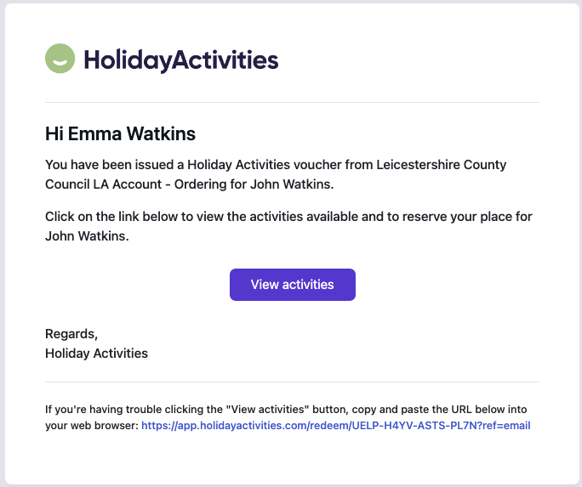

Your voucher will have a unique code, like below:

