# FORM B



**Best Endeavours & Reasonable Adjustments Concerns Form (Form B)**

**This form is to be completed by a parent/carer, professional, or advocate if it is felt that after a meeting, reasonable adjustments and/or best**

**endeavours are not in place.**

**This form has been completed by (Insert name and role) on (insert date). In completing this form, the following sources have been drawn on:**

**Reference to the original paperwork, including form A**

**Conversations with relevant parties**

**Reference to the supporting guidance**

**Examples of practice delivered to other children with**

**similar needs in similar schools within Leicestershire**

**Other**

**What was the original concern?**

8

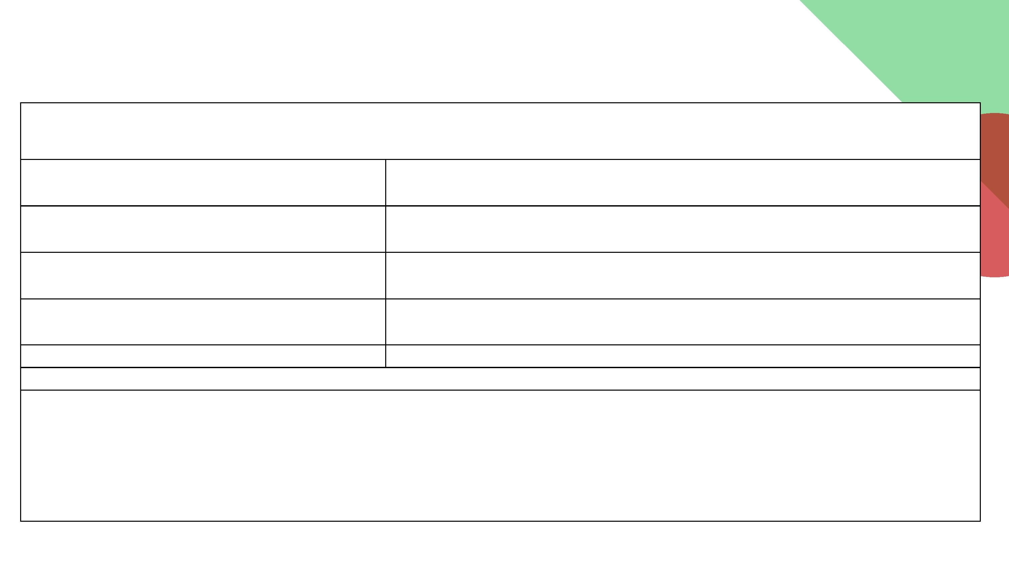

**Best Endeavours & Reasonable Adjustments Concerns Form (Form B)**

**This form is to be completed by a parent/carer, professional, or advocate if it is felt that after a meeting, reasonable adjustments and/or best**

**endeavours are not in place.**

**Based on your review, is there evidence to suggest that the concerns about the child are SEND related and well placed?**

**What impact is this having on the child?**

**What are the views of the child?**

**Drawing on your evidence base, is it your judgement that this falls within the ‘best endeavours/reasonable adjustments’ duty?**

9



**Best Endeavours & Reasonable Adjustments Concerns Form (Form B)**

**This form is to be completed by a parent/carer, professional, or advocate if it is felt that after a meeting, reasonable adjustments and/or best**

**endeavours are not in place.**

**Where this is the case, what needs to be done, by whom and by when? What needs to happen to address the disadvantage identified?**

**Actions**

**By whom**

**By when**

**How and when will the implementation of these actions be reviewed?**

**This document was completed by:**

**(Insert Name Role and Signature)**

**This document was Agreed/Not Agreed by the School representative:**

**Name Role and Signature**

**On Insert date**

**And shared with the school on (insert date)**

**Where the school does not agree with the recommendations, outline the reasons here** and bring in a third party service to support.

Third party service contacted

10

